Final report for project “Winter colony losses and renewal of honey bee livestock in Austria and in Czech Republic” (69p11)

Written by Zdeněk Klíma, Jiří Danihlík and Robert Brodschneider
November 2014

The pilot cooperation between the Czech Republic and Austria in honey bee research field started thanks to the AKTION program in February 2014. Czech researches Jiří Danihlík and Zdeněk Klíma went to the Karl-Franzens Universität Graz to participate in a meeting “Monitoring of honey bee colony losses”. Zdeněk Klíma and Jiří Danihlík presented the beekeeping situation in the Czech Republic and were introduced into the COLOSS standards of estimating honey bee colony losses during winter. The standardized method for the honey bee colony losses monitoring was established during the seminar. All materials were translated into the Czech language and used for the Czech survey.
The Czech survey was open for all beekeepers in the Czech Republic from March to May 2014. Beekeepers were informed about the running survey by beekeeping magazines (Český Coloss se rozhýbal, Moderní včelař 1/2014; Pomozte zmapovat počty vyzimovaných včelstev, Moderní včelař 2/2014), by the Internet (www.psnv.cz), the information was also spread during lectures and presentations given at meetings. 556 Czech beekeepers took part in this survey (which is roughly 1.2 % of total Czech beekeepers), in total 10458 colonies were included in the survey. Participating beekeepers were from various parts of the Czech Republic (see Fig. 1 for geographic distribution). Obtained data were also submitted to the international group COLOSS for general evaluation and a press release. The Czech data are included in the survey which was done in Europe and also in some non-European countries. COLOSS published a press release with these results in July 2014 and a scientific report is under preparation by the research group.

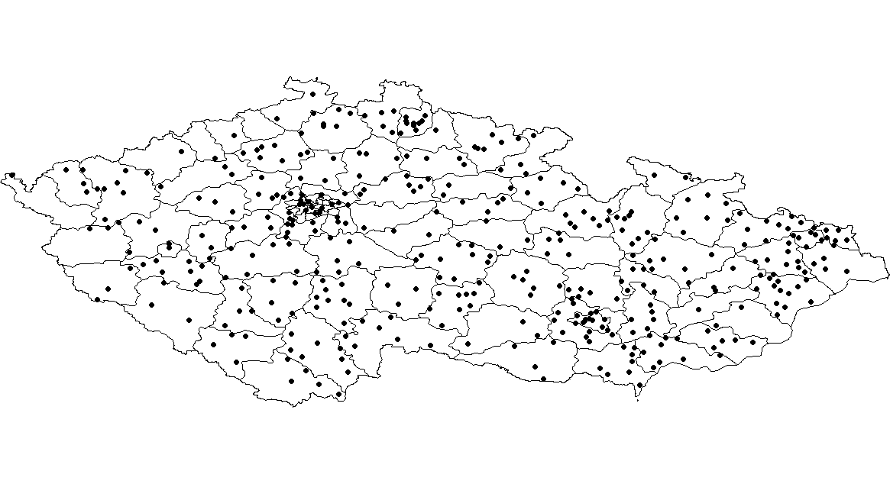
Fig. 1: Distribution of participating beekeepers in the Czech survey, each dot represents at least one beekeeper (participant) in our study.

Fig. 2: Winter loss rate (and 95% confidence interval) of honey bee colonies in Austria (red) and the Czech Republic (blue).

Robert Brodschneider from Karl-Franzens Universität Graz visited the Czech team in Olomouc in 10 – 13 July 2014. During their visit the results from the winter survey were analysed and discussed. Outcomes were prepared for publication during the COLOSS conference in Murcia 6 - 8 September 2014, Spain. Questionnaire for a follow up study was translated from German language into the Czech and the on-line survey was prepared for invited beekeepers. A four hours long seminar about honey bee nutrition was given by the Austrian partner in Olomouc. Vets, academic researchers, students and beekeepers visited this seminar.
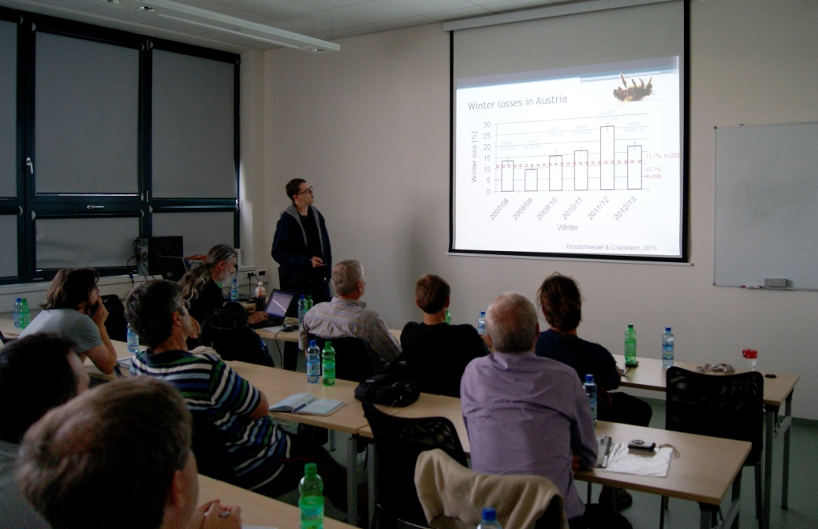
Fig. 3: Robert Brodschneider during the seminar at Palacký University in Olomouc in July 2014.
The follow up survey on renewal of honey bee livestock was running in October in parallel in Austria and in the Czech Republic. Beekeepers which answered the winter survey and agreed with the participation in summer survey were invited for the follow up survey by e-mail. Answers were collected by our partner in Graz using Limesurvey-software. 341 of totally asked beekeepers (78.9 %; 432) answered the questionnaire in the Czech Republic. 381 of totally asked beekeepers (78.1 %; 488) answered the questionnaire in Austria.
Jiří Danihlík travelled to Graz at the beginning of November (2 – 5 November) to analyse the data together with Robert Brodschneider. Comparisons and graphs were preliminarily prepared for publication in an international beekeeping journal. The Czech data from the winter loss survey were finalized and prepared for a publication in Czech beekeeping journal “Moderní včelař” in the last issue in 2014.
This project brought the cooperation between Czech and Austrian partner in honey bee research field. The international survey in honey bee colony losses was for the first time done in the Czech Republic and the country is now a participating in the international work group. Thanks to the colleagues in Graz it was possible to collect data of the Czech colony losses during winter 2013/2014 and Czech experts were introduced into methodology of analysing the data. The comparison of Czech and Austrian results with each other and also other datasets that was obtained the same way shows that honey bee colony losses were low in general in that particular year (2013/14). In Czech Republic, colony losses were very low (6.6%), also in comparison with other countries. The loss rate in Austria was 12.8% and of all participating countries in the COLOSS survey it was about 9% in that winter. The follow up study gave the information about colony renewal in the Czech Republic and also in Austria, results will be prepared for publication in both countries. In general, beekeepeing by the means of breeding queens is very similar in both countries. Beekeepers produce enough new queens and colonies to not even restore winter losses, but also allow extension of the beekeeping section.
The started cooperation between Czech and Austrian team will be continued in the next year in honey bee colony losses monitoring and honey bee immunity research, supported by the AKTION 71p6 “Honey bee colony losses in Austria and the Czech Republic and relation to the bee immune system”.

Attachment 1: Abstract from the COLOSS conference in Murcia 6 – 8 September 2014
Attachment 2: Presented poster from the COLOSS conference in Murcia 6 – 8 September 2014
Attachment 3: COLOSS press release
Attachment 4: Český Coloss se rozhýbal, Moderní včelař 1/2014
Attachment 5: Pomozte zmapovat počty vyzimovaných včelstev, Moderní včelař 2/2014

