Projekt 84p16

Metabolite profiling of natural substances in man: In vitro study from faecal bacteria to colon carcinoma cells (Caco-2)

Zuzana Racova^{1*}, Eva Anzenbacherova², Stefan Poschner³, Barbora Papouskova⁴,
Pavla Kucova⁵, Julia Clara Gausterer⁶, Franz Gabor⁶, Milan Kolar⁵, Pavel Anzenbacher¹

¹Department of Pharmacology, Faculty of Medicine and Dentistry, Palacky University Olomouc, Czech Republic
²Department of Medical Chemistry and Biochemistry, Faculty of Medicine and Dentistry, Palacky University Olomouc, Czech Republic
³Division of Clinical Pharmacy and Diagnostics, Department of Pharmaceutical Chemistry, University of Vienna, Austria
⁴Department of Analytical Chemistry, Faculty of Science, Palacky University Olomouc, Czech Republic
⁵Department of Microbiology, Faculty of Medicine and Dentistry, Palacky University Olomouc, Czech Republic
⁶Department of Pharmaceutical Technology and Biopharmaceutics, University of Vienna, Austria

*Corresponding author: Mgr. Zuzana Racova, Ph.D., Department of Pharmacology, Faculty of Medicine and Dentistry, Palacky University Olomouc, Hnevotinska 3, 779 00 Olomouc, Czech Republic, TELEPHONE: +420-585 632 560, E-MAIL: zuzu.matuskova@seznam.cz

Abstract

Flavonoids and anthocyanidins are compounds present in fruits and vegetables. They can be absorbed from the intestine to the bloodstream in man and also can pass into the large intestine, where are various different species of bacteria and enzymes in intestinal cells. The aim of the present work was to investigate the intestinal metabolism of selected dietary polyphenol and polyphenol glycosides (quercetin, cyanidin-3-O-glucoside, cyanidin-3-O-galactoside, and delphinidin-3-O-galactoside) by human faecal bacteria. Moreover, metabolites formed from these compounds were also studied with human colon carcinoma cells (Caco-2). 1 g of human stool was mixed in Mueller-Hinton broth and then incubated with selected compounds for 6 or 20 h at 37°C. Subsequently, the reaction was stopped by cooling down and then was precipitated. Prepared samples were injected into LC/MS. Metabolites observed in this study were further tested on Caco-2 cells. These experiments were performed with RPMI-1640 medium and test compounds (4-hydroxybenzoic acid, 3,4-dihydroxybenzoic acid, 2,4,5-trihydroxybenzaldehyde, and 2,4,6-trihydroxybenzaldehyde). The incubation time and the preparation of samples for LC/MS were the same as in the case in the study with bacteria. Main metabolic pathways were deglycosylation, hydrogenation, methylation, hydroxylation, and decomposition. Metabolites formed by faecal bacteria were further glucuronidated or methylated by intestinal enzymes. In conclusion, natural compounds can be metabolized by intestinal bacteria and metabolites created in the intestine can further pass into intestinal barrier and can be metabolized in the intestinal cells. This metabolite profiling of natural compounds has helped to better understand their metabolism in the intestine in man.

Introduction
Fruits and vegetables are generally accepted as healthy food as they are known to contain many compounds with beneficial effects on human health when they are consumed in an adequate amount [1, 2]. There are present for example flavonoids or anthocyanidins which may possess anti-inflammatory, neuro-protective, anti-microbial, anti-viral and anti-thrombotic properties [3-5] and they can be used for disease prevention or as a supplementation in the treatment of diseases.
One of these flavonoids of interest is quercetin, a compound with a flavonol structure, which is naturally found in fruits, vegetables, and nuts in its various glycosylated forms. For example, quercetin-3-O-galactoside is contained in plums, mango, or berries, similarly as quercetin-3-O-glucoside which is moreover present in onions, black beans, or black olive. Quercetin-3-O-rutinoside was found in tomatoes and buckwheat besides already mentioned fruits and vegetables [6-8]. Other naturally occurring polyphenols include various glycosides of cyanidin and delphinidin, which are found in several types of berries, black olives, or black beans [8-11].
These flavonoids can be absorbed from the intestine but also can pass into the large intestine, where are various different species of bacteria (with dominant bacterial phyla of Bacteroidetes, Firmicutes, Actinobacteria, Proteobacteria, and Verrucomicrobia [12]). These bacterial species are in a total amount of up to 10¹⁰ – 10¹² colony forming units (CFU)/ml intestinal content [13] and express enzymes with the ability to produce various differently hydroxylated aldehydes and acids [14]. Besides deglycosylation of naturally occurring polyphenols with sugar moieties and deconjugation of metabolites formed by biotransformation enzymes in the liver and in the intestinal wall, gut microbiota can also interconvert various conjugates. For example, the conversion of cyanidin-3-O-rutinoside to cyanidin-3-O-glucoside was observed during in vitro test in the presence of 1% active gut flora with active α,L-rhamnosidase and β,D-glucoside [15]. Detailed pathways for degradation products following oral administration and any effects of formed metabolites on the human intestinal wall are still unknown. The aim of the present work was therefore to investigate the intestinal metabolism of selected dietary polyphenol and polyphenol glycosides (quercetin, cyanidin-3-O-glucoside, cyanidin-3-O-galactoside, and delphinidin-3-O-galactoside; shown in Fig. 1) by human faecal bacteria and to determine whether metabolites formed from these compounds, namely 2,4,5-trihydroxybenzaldehyde, 2,4,6-trihydroxybenzaldehyde, 3,4-dihydroxybenzoic acid, and 4-hydroxybenzoic acid, are further metabolized in human Caco-2 colon carcinoma cells. Furthermore, possible harmful effects of these biotransformation products on the human organism as well as the gut microbiota have been discussed.

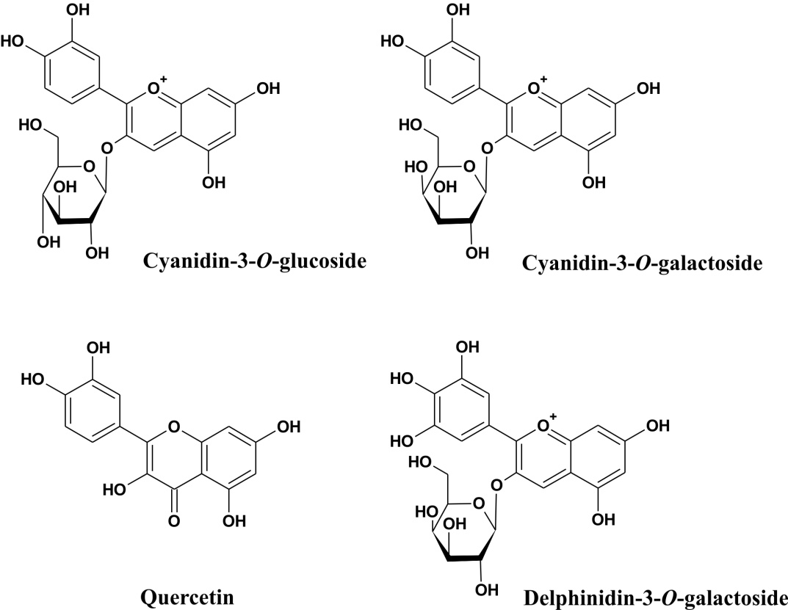

Fig. 1. Chemical structures of selected naturally occurring polyphenols and polyphenol glycosides investigated in this work.

Materials and Methods
Chemicals
Human Caco-2 colon carcinoma cells were purchased from the American Type Culture Collection (ATCC; Manassas, VA, United States). Mueller-Hinton broth (MHB) for bacterial incubation was purchased from Bio-Rad (Hercules, California, USA). Roswell Park Memorial Institute (RPMI) 1640 medium, PenStrep®-solution, fetal bovine serum, and Dulbecco’s phosphate buffered saline (DPBS) for experiments with Caco-2 cells were obtained from the Invitrogen Corporation (Thermo Fisher Scientific, Inc., Waltham, MA, United States). Standards of quercetin, 2,4,5-trihydroxybenzaldehyde, 2,4,6-trihydroxybenzaldehyde, 3,4-dihydroxybenzoic acid, and 4-hydroxybenzoic acid as well as dimethylsulfoxide (DMSO; for molecular biology) were purchased from Merck KGaA (Darmstadt, Germany). Cyanidin-3-O-glucoside chloride, cyanidin-3-O-galactoside chloride and delphinidin-3-O-galactoside chloride were obtained from Phytoplan (Heidelberg, Germany). Methanol and acetonitrile (HPLC-gradient grade) were purchased from VWR International (Radnor, Pennsylvania, USA), formic acid was obtained from Lach-Ner (Neratovice, Czech Republic). Fresh ultra-pure water was prepared via ULTRAPUR laboratory unit (Watrex Praha, Prague, Czech Republic).

Faecal bacteria sample preparation
Fresh human faecal bacteria were obtained from a sample of faeces obtained from a healthy male volunteer (39 years old). For extraction, 1 g of human faeces was mixed with 5 ml of fresh Mueller-Hinton broth (MHB) and incubated for 2 h at 35 °C (in order to prevent the loss of bacteria present in the sample, a lower temperature than 37 °C was set). Afterwards, the inoculated broth was diluted ten-fold and divided into 1.5 ml test-tubes. To elucidate the metabolism of quercetin, cyanidin-3-O-glucoside chloride, cyanidin-3-O-galactoside chloride, and delphinidin-3-O-galactoside chloride by the faecal bacteria, all test compounds were dissolved in ultrapure water or in 60% DMSO (for quercetin) to give a final concentration of 2.55 mM. Afterwards, 20 µl of these solutions were added to the diluted inoculated MHB to obtain a final concentration of 50 µM of the respective test compounds (for quercetin, final DMSO concentration was 1.2 %) as a suitable concentration to detect metabolites and a loss of parent compounds. Prepared solutions were incubated at 37 °C (like in human colon) for 6 or 20 h. Shorter incubation time was not sufficient for the detection of metabolites (we have already tested it) and contrary typical experimental time 24 hours could be too much longer to study metabolism selected compounds. Subsequently, all potential metabolic reactions were stopped by cooling the samples on ice and samples were centrifuged at 18 000 g for 10 min at 4 °C. 100 µL of supernatants were mixed with 400 µL of a mixture of methanol/acetonitrile/water (4:5:1; v/v/v). Subsequently, samples were centrifuged at 18 000 g for 10 min at 4 °C again and clear supernatants (quercetin samples were additionally acidified with 0.1% formic acid) were injected onto the LC/MS column.
Sediment of each sample obtained after first centrifugation was mixed with 200 µl of fresh ultra-pure water with lysozyme and sonicated for 3 × 10 s. Samples were then centrifuged at 18 000 g at 4 °C for 10 min. 100 µl of supernatants were further prepared for LC/MS analyses the same way as in samples after incubation with bacteria.
All control samples (fresh MHB containing no faecal bacteria in the presence or absence of the test compounds, and inoculated MHB containing faecal bacteria but no test compounds) were treated the same way to exclude any bias due to spontaneous degradation of the test compounds or spontaneous endogenous metabolite formation in the faecal bacteria.

Bacterial sample preparation for MALDI-TOF analyses
A small amount of bacterial culture with a toothpick was applied on the MALDI-TOF MS target plate that was overlaid with 100 µl of α-kyano-4hydroxycinnamic acid. The plate was inserted into the instrument. Measured MS spectra were compared with the library of mass spectra of microorganisms (MALDI Biotyper Systems, Billerica, MA, US) which serves to identify microorganisms at the genus, species and strain level.

Caco-2 cell culture and sample preparation
Human Caco-2 colon carcinoma cells were routinely cultivated at 37 °C (95% humidity and 5% CO₂) in RPMI-1640 medium containing phenolred as indicator, fortified with 1% PenStrep®-solution and 10% fetal bovine serum. All experiments were performed in triplicates during the exponential growth phase of the cell line. For the metabolism studies, cells were seeded in 6-well-plates at a density of 3.0 x 10⁵ cells per well and allowed to attach for 4 days. To elucidate the metabolism of 4-hydroxybenzoic acid, 3,4-dihydroxybenzoic acid, 2,4,5-trihydroxybenzaldehyde, and 2,4,6-trihydroxybenzaldehyde, all four test compounds were dissolved in sterile-filtered DMSO and added to the culture medium at a concentration of 50 µM (final DMSO concentration was 0.1 %). After incubation for 6 or 20 h, respectively (the incubation time as well as the concentration was selected for the same reason as in the case in study with bacteria), cellular supernatants were removed and the cell layers washed using cold (4 °C) DPBS solution. Cell layers and cellular supernatants were then stored at -80 °C until further analysis. Control samples containing no test compounds were processed with each batch to exclude any endogenous metabolite formation by the Caco-2 cells and spiked media were also incubated in the absence of Caco-2 cells to monitor any possible degradation of the test compounds over the investigated time-span. Prior to the preparation of the LC/MS samples, all samples were thawed at room temperature, then 400 µl of ultra-pure water was added to all samples and all contents of the wells were transferred into clean 1.5 ml test-tubes. Subsequently, 200 µl of resuspended cells were lysed by Precellys kit (Bertin Technologies SAS, Montigny-le-Bretonneux, France) for 4 ×10 s at 7 500 rpm. The volume of 50 µl of homogenized suspension was mixed with 200 µl of a mixture of methanol/acetonitrile/water (4:5:1; v/v/v). Subsequently, samples were centrifuged at 18 000 g for 10 min at 4 °C and 3 µl of the clear supernatants were injected onto the LC/MS column.

LC/MS analyses
All samples were analyzed using a Waters ACQUITY I-Class UPLC system (Waters, Milford, MA, USA), equipped with a binary solvent manager, an autosampler (kept constantly at 10 °C), and a column oven (set to 40 °C). Chromatographic separation was performed on an Acquity UPLC BEH C18 analytical column (100 mm × 2.1 mm i.d., with 1.7 µm particles) from the same company. Mobile phase consisted of water containing 0.01% formic acid (solvent A) and methanol (solvent B). The linear gradient profile was as follows: 0 – 8 min. 0 % B, 8 – 11 min. 0 – 100 % B, 12 – 13 min. 100 – 0 % B, 13 - 15 min. 0 % B with flow rate 0.25 ml/min. The injection volume was 3 µl.
A Waters Synapt G2-S Mass Spectrometer (Waters, Manchester, UK) was connected to the UPLC system via an electrospray ionization (ESI) interface. The ESI source operated in positive and negative mode with a capillary voltage of 2.20 kV and -1.80 kV, respectively, and the sampling cone worked at 40 V. The source temperature and the desolvation temperature were set to 110 °C and 220 °C, respectively. The cone and desolvation gas flows were 30 l/h and 480 l/h. Data were acquired from 50 to 1500 Da with a scan time of 0.1 s. The mass spectrometer was calibrated over a mass range from 50 to 1500 Da using a solution of sodium formate in acetonitrile. Data were automatically centroided and mass corrected during acquisition using a leucine-enkephalin external reference with the concentration of 20 µg/l in a mixture of water/acetonitrile/formic acid (100:100:0.2) and flow rate of 10 µl/min. Data acquisition was achieved using two interleaved scan functions (MS^{E} experiments), which enabled the simultaneous acquisition of both low-collision-energy (low CE) and high-collision-energy (high CE) mass spectra from a single experiment. The low trap CE was set to 4 V and the low transfer CE was set to 0 V for Function 1. For Function 2 (high CE), the trap CE was set to 4 V and the transfer lenses were ramped CE in the range of 5 – 20 V.

Data analysis and statistics
Data from experiments were evaluated semiquantitatively where measured data of parent compounds were compared with measured data of metabolites. Results were expressed as a percentage. The loss of parent compounds in experimental samples with Caco-2 cells was statistical analysed using non-parametric Mann-Whitney U test on the significance level of 0.05.
Results and Discussion

Bacterial composition in human faecal sample
All experiments were performed with fresh human faecal bacteria [16, 17]). In these faecal samples, an aerobic cultivation method with MALDI-TOF MS instrument was used for the qualitative and quantitative evaluation of bacterial composition. Citrobacter freundii, Enterobacter cloacae, Enterococcus faecalis, Escherichia coli, and Klebsiella pneumoniae were identified as the most represented facultative anaerobic bacteria species in our human faecal sample with the concentration of 10⁷ CFU/ml of each. These species are commonly present in the physiological flora of the intestine [18]. Pathogenic genera of bacteria like Campylobacter, Salmonella, Shigella, or Yersinia have not been proven in the faecal sample.
It is already known that Citrobacter freundii produces hydrogen from glucose, sucrose, or lactose [19]; therefore, the hydrogenation could be observed in our experiments. On the contrary, in the presence of oxygen, Enterococcus faecalis produces extracellular reactive oxygen species that can react with other extracellular molecules [20]. Although, it does not display typical oxygen-dependent pathways such as a tricarboxylic acid cycle and oxidative phosphorylation because it lacks key enzymes (such as fumarase and aconitase), it is able to respire aerobically using a cytochrome bd terminal oxidase when grown in the presence of hemin [21]. Oxidation reactions, such as a transformation of demethylmenaquinol into demethylmenaquinone, lead to a one-electron reduction of O₂ to the formation of superoxide radical and subsequently to hydrogen peroxide. These pathways are also known in Escherichia coli species [22]. Therefore, oxidative reactions could be observed in our experiments as well. The lumen of the intestine is not strictly anaerobic; some molecules of oxygen are present inside and values of pO₂ for various sites along the intestine indicate its heterogeneity. Although the oxygen concentrations drop sharply to near anoxia towards the centre of the lumen, facultative anaerobic bacteria who settled within 1250 µm from the epithelial surface still have molecules of oxygen available [23]. These pieces of knowledge show that metabolic reactions of bacteria can be a reduction but also an oxidation.
All metabolites measured in our experiments were produced from the aglycone which means that if the glycoside was used a substrate, the sugar moiety was cleaved from the glycoside molecule at first. It is already known that O-deglucosylation of anthocyanins is caused by an action of β-glucosidases. Several bacteria with an activity of these enzymes are dominant members of the human intestinal microbiota. These include bacteria belonging to the family of Bifidobacteriaceae (Bifidobacterium adolescentis, Bifidobacterium longum), Enterococcaceae (Enterococcus faecalis), Bacteriodaceae (Bacteroides ovatus, Bacteroides uniformis), Lactobacillacaeae, Tannerellaceae (Parabacteroides distasonis), or Enterobacteriaceae (Escherichia coli) [24-27]. Some of them are mainly known for its probiotic effect. These bacteria are mainly found in milk products, beverages and some dietary supplements [28].

Metabolism of quercetin by human faecal bacteria
Quercetin, a flavonol-structured aglycone, was chosen for our study predominantly due to its low bioavailability. In fact, a sugar moiety of quercetin glycosides is a major determinant of their absorption and bioavailability. There are some explanations, glucosides of quercetin are more water soluble than their aglycone, moreover, they are absorbed through sodium-dependent glucose transporter 1 (SGLT1) that is located in apical membrane of small intestinal villi. On the contrary, quercetin aglycone is not a substrate of SGLT1 [29-31]. Other possible transport way of quercetin glycosides (such as quercetin glucoside, quercetin galactoside, quercetin arabinoside) into intestinal cells is their hydrolysis by lactase phlorizin hydrolase (LPH) that is glycoside hydrolase on the outside of the brush border membrane of the small intestine. Liberated aglycone is then absorbed across the intestinal epithelium primarily by passive diffusion and secondarily by organic anion transporting polypeptide (OATP). Alternatively it goes back through efflux multidrug resistance-associated protein 2 (MRP2) into intestinal lumen and passes along small intestine to the large intestine [32, 33]. Therefore, quercetin without sugar moiety reaches large intestine more likely than its glycoside and there is a certain possibility of metabolism quercetin by intestinal bacteria. For this reason, quercetin was selected for our study.
As results show, quercetin was partly absorbed into faecal bacterial cells during 6 h incubation. During this time-span was quercetin aglycone metabolized to four metabolites; three of them were detected only in MHB and the fourth was measured only in the bacterial cells (Table 1). The total number of quercetin metabolites measured after incubations was seven, where major metabolites were observed in MHB after 6 h as well as after 20 h incubation and were detected by LC/MS in 1.00 and 1.07 min, respectively, with [M-H]⁻ 157. Six metabolites were detected in MHB, not inside bacterial cells, and only one metabolite with the elementary composition C₁₅H₈O₇ was trapped inside the cells and was not further excreted. Metabolic reactions included in the experiment with quercetin and faecal bacteria were mainly decomposition. Molecule of quercetin was decomposed to 4-hydroxybenzoic acid (Fig. 2) and two metabolites with [M-H]⁻ 157, probably 5-oxohex-2-enedioic acids with an E- or Z-configuration (Fig. 3). Retention times of the latter metabolites are closed; therefore we presume that there is an E-Z isomerism. Metabolite 5-oxohex-2-enedioic acid with the Z-configuration, also known as 4-oxalocrotonic acid, has been already studied by Sala-Trepat et al. (1971) where authors describe an aerobic catabolism of catechol in bacteria (catechol group is included in quercetin molecule). One of the decomposition pathways of catechol is a meta-ring cleavage pathway that leads through 2-hydroxymuconic semialdehyde, 2-hydroxymuconic acid, and 4-oxalocrotonic acid to the formation of pyruvate and acetaldehyde [34, 35]. However, the cleavage pathway can obviously lead to the formation of both isomers (with a Z- but also E-configuration, Fig 4.). We do not have commercial standards of these compounds; therefore, it is our presumption. The pathway of the conversion of quercetin to catechol in bacterial cells probably leads through 4-hydroxybenzoic acid (also detected in our experiment, Fig. 2.). This intermediate is subsequently metabolized to 3,4-dihydroxybenzoic acid and this is afterwards transformed into catechol [36]. Nevertheless, there is also other possibility of the formation of metabolites with [M-H]⁻ 157, a quercetin decomposition through hydroxyquinol. On this pathway, maleylacetic acid (or its enol form 3-hydroxymuconic acid) is produced from hydroxyquinol and this acid is subsequently metabolized to 3-oxoadipate whose products participate in the tricarboxylic acid cycle [35]. Maleylacetic acid (with also [M-H]⁻ 157) is 4-oxohex-2-enedioic acid with the Z-configuration. If our metabolite is maleylacetic acid, there is also possibility a formation both isomers (with the Z- but also E-configuration, Fig. 4).
Other quercetin metabolite measured in experimental samples after 6 as well as after 20 h incubation was 3´-O-methyldihydroquercetin or 4´-O-methyldihydroquercetin (Fig. 5), measured only in MHB. Its formation was probably caused by hydrogenation of quercetin to form taxifolin that was subsequently O-methylated in position 3´- or 4´. In view of the fact that taxifolin is dihydroquercetin, metabolites measured in our experiment can be also termed 3´- or 4´-O-methyltaxifolin. The presence of 3´-, 4´-, but also 7´-O-methyltaxifolin in faeces was already observed by Yang et al. [37] and our study confirmed that O-methylation of dihydroquercetin in the intestine can be caused by intestinal bacteria. The formation of O-methylated metabolite was probably caused by O-methyltransferases that are present in bacterial cells [38].
Metabolite with the elementary composition C₁₅H₈O₇ was detected only inside bacteria after 6 h incubation and its formation was probably caused by quercetin dehydrogenation. The ability to dehydrogenate polyphenolic compounds (such as quercetin) is known in polyphenol oxidase (PPO) enzymes. They catalyze oxidation of o-diphenols to the corresponding o-quinones by a catecholase/diphenolase activity in the presence of its co-substrate oxygen [39, 40]. These enzymes are present, among other things, also in bacterial cells; therefore, we detected C₁₅H₈O₇ metabolite only inside bacteria. Two last metabolites with [M-H]⁻ 300 and elementary composition C₁₂H₁₂O₉ were formed only after 20 h incubation in MHB probably by decomposition of quercetin (their exact molecule structure is not known).
Results show that the parent compound and only one metabolite entered into bacterial cells, schematic drawn in Fig. 6. Nevertheless, the differently long incubation uncovered the mechanism of studied metabolism only partially. Quercetin metabolites observed in our study are probably only a fraction of complex metabolism of quercetin. According the literature, we drawn the mechanism of quercetin metabolism by intestinal bacteria with our observed metabolites which are signed bold (Fig. 7). All experimental analyses were compared with analyses of control samples. Metabolites were not present in control samples and the parent compound quercetin was present in control sample (control with MHB and the parent compound) even after 20 hours. Therefore, quercetin did not spontaneously decompose and all detected metabolites were produced by an action of bacteria.

Table 1. LC/MS screening of quercetin metabolites present outside or inside faecal bacteria after 6 h or 20 h incubation.
Elementary composition | Retention time  [min] | Measured ion  [M-H]⁻ | Conversion of quercetin  to metabolite  (semiquantitative evaluation) |  |  |  |  | Reaction of metabolite formation | Suggested metabolite
 |  |  | MHB |  | Bacteria
 |  |  | 6 h | 20 h |  | 6 h | 20 h
C₆H₆O₅ | 1.00 | 157.0137 | +++ | +++ |  | - | - | decomposition | (E)-5-oxohex-2-enedioic acid  (Z)-5-oxohex-2-enedioic acid
C₆H₆O₅ | 1.07 | 157.0137 | +++ | +++ |  | - | - | decomposition
C₇H₆O₃ | 1.38 | 137.0239 | - | + |  | - | - | decomposition | 4-hydroxybenzoic acid
C₁₆H₁₄O₇ | 1.74 | 317.0659 | + | + |  | - | - | hydrogenation, methylation | 3´-O-methyldihydroquercetin
C₁₂H₁₂O₉ | 2.90 | 300.0481 | - | + |  | - | - | decomposition | M₁
C₁₂H₁₂O₉ | 3.14 | 300.0481 | - | + |  | - | - | decomposition | M₂
C₁₅H₈O₇ | 10.79 | 299.0192 | - | - |  | + | - | desaturation | 2-(3-hydroxy-4-oxophenyl)-5-hydroxychroman-3,4,7-trione
M₁ and M₂ represent unknown metabolites.
Signs show the conversion of quercetin to metabolite in the sample: -, 0 %; +, 1 - 9 %; ++, 10 - 19 %; +++, 20 - 30 %.

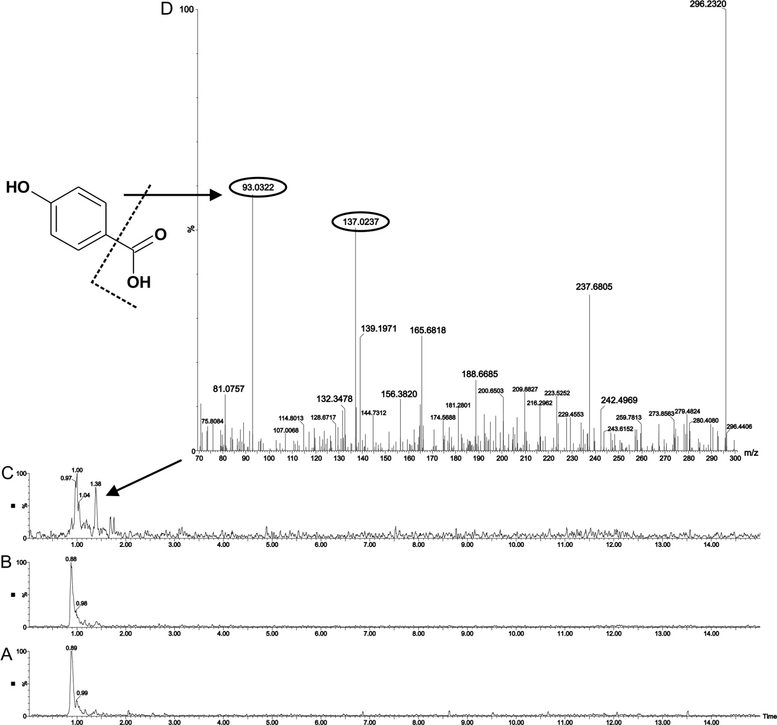
Fig. 2. Representative LC chromatograms of control sample with quercetin (A), experimental sample incubated 6 h (B), and experimental sample incubated 20 h (C). Figure above represents MS spectrum of signal detected in 1.38 min (D) in experimental sample incubated 20 h. The m/z marked in a circle in mass spectrum corresponds with [M-H]⁻ of 4-hydroxybenzoic acid (chemical structure is shown).

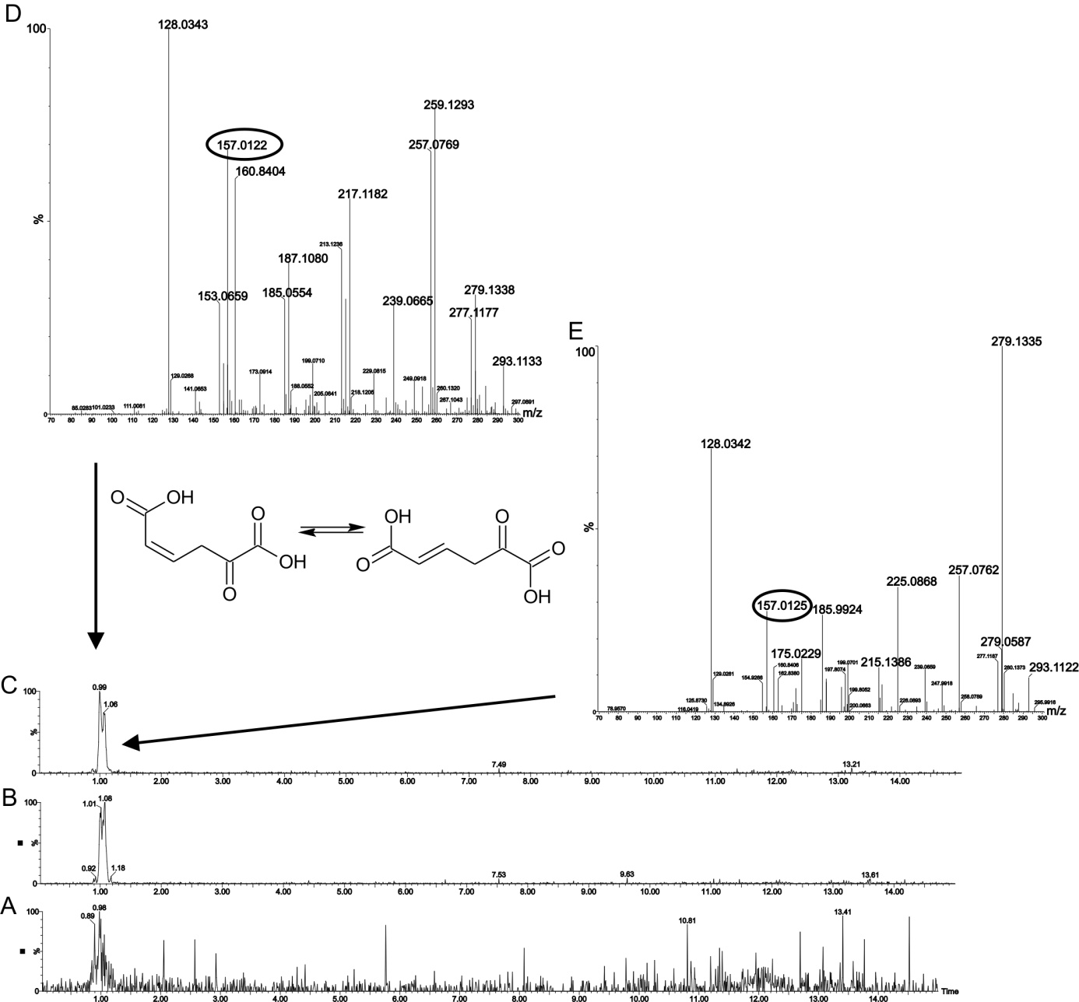
Fig. 3. Representative LC chromatograms of control sample with quercetin (A), experimental sample incubated 6 h (B), and experimental sample incubated 20 h (C). Figures above represent MS spectra of signals detected in 1 min (D) and 1.07 min (E) in experimental samples. The m/z marked in a circle in mass spectra corresponds with [M-H]⁻ of 5-oxohex-2-enedioic acid. Two signals with the same m/z in mass spectrum may indicate E-Z isomerism. Chemical structures in E- and Z-configuration of 5-oxohex-2-enedioic acid are shown.

(Z)-5-oxohex-2-enedioic acid | (E)-5-oxohex-2-enedioic acid
(Z)-4-oxohex-2-enedioic acid | (E)-4-oxohex-2-enedioic acid
Fig. 4. Molecules of suggested quercetin metabolites in both Z- and E- configurations.

Metabolism of quercetin metabolites by Caco-2 cells
The formation of metabolites by intestinal bacteria is not end-process of parent compounds in the intestine. Their destiny depends on enzymes present in intestinal cells. Our aim was also the study of metabolism of our observed metabolites. We expect that metabolites formed by intestinal microflora can enter into intestinal cells and there can be metabolized by other enzymes present inside of cells. This study was performed with 4-hydroxybenzoic acid that was formed from quercetin by faecal bacteria. 4-hydroxybenzoic acid was added to Caco-2 cells (which are the human epithelial colorectal adenocarcinoma cells) and was incubated the same time as in previous study of quercetin metabolism by faecal bacteria. Our results show that 4-hydroxybenzoic acid was slightly glucuronidated by phase 2 enzymes (drawn in Fig. 7). Only one metabolite was detected in broth after 6 h incubation in very low concentration. Other metabolites were not observed neither after 6 h nor 20 h incubation as well as neither in broth nor inside Caco-2 cell lines. A decrease of a concentration of 4-hydroxybenzoic acid was not observed.
The effect of 4-hydroxybenzoic acid on the Caco-2 cells was not toxic; cells appeared after 6 h as well as 20 h the same as before experiment. This compound is a widely used industrial chemical, used as an intermediate in dyes, pesticides, cosmetics and drugs, as a food preservative, corrosion inhibitor, anti-oxidant, and emulsifier. 4-hydroxybenzoic acid does not appear to be harmful to health; moreover, it is an intermediate that is converted in the intestine to other metabolites.

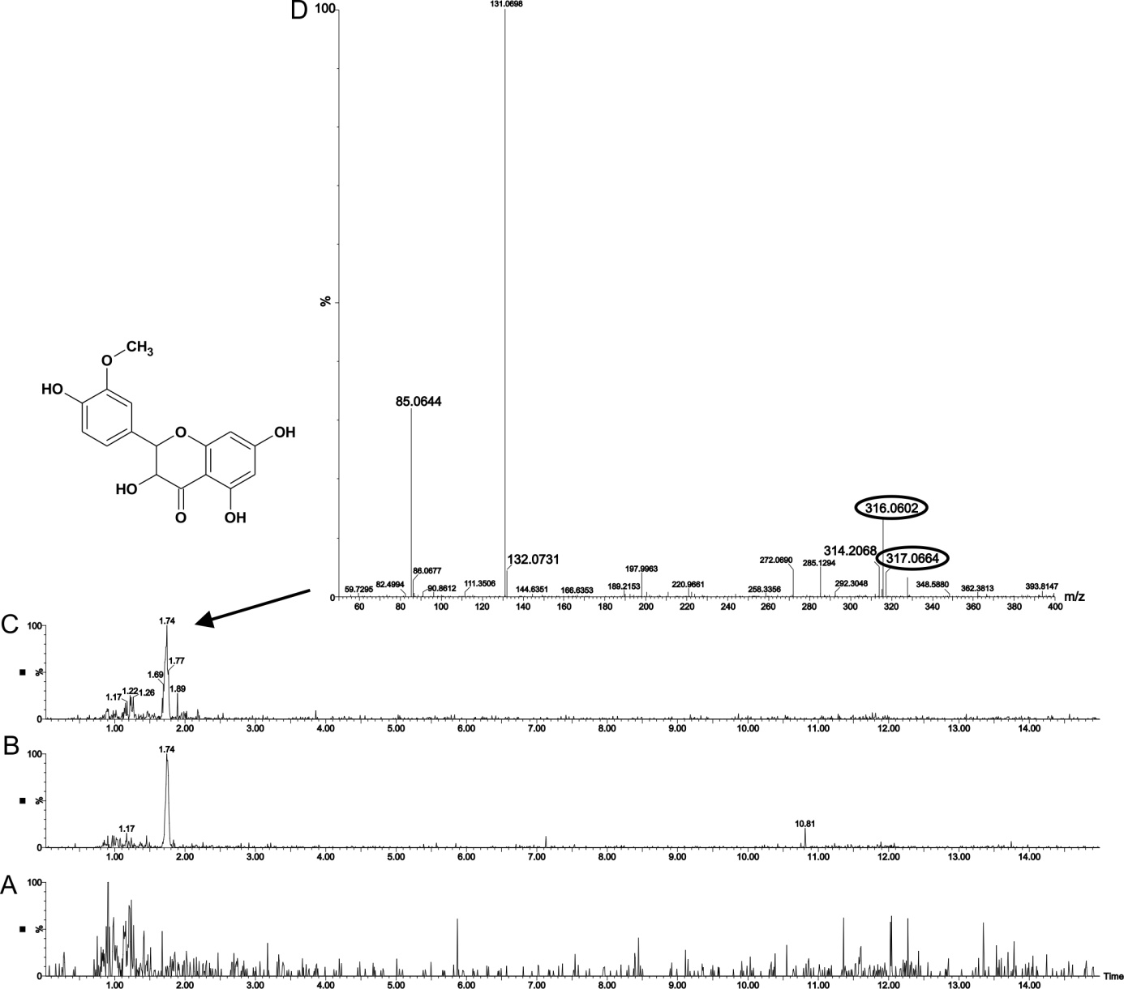
Fig. 5. Representative LC chromatograms of control sample with quercetin (A), experimental sample incubated 6 h (B), and experimental sample incubated 20 h (C). Figure above represents MS spectrum of signal detected in 1.74 min (D) in experimental samples. The m/z marked in a circle in mass spectrum corresponds with [M-H]⁻ of O-methylated dihydroquercetin (such as 3´-O-methyltaxifolin, the structure is shown).

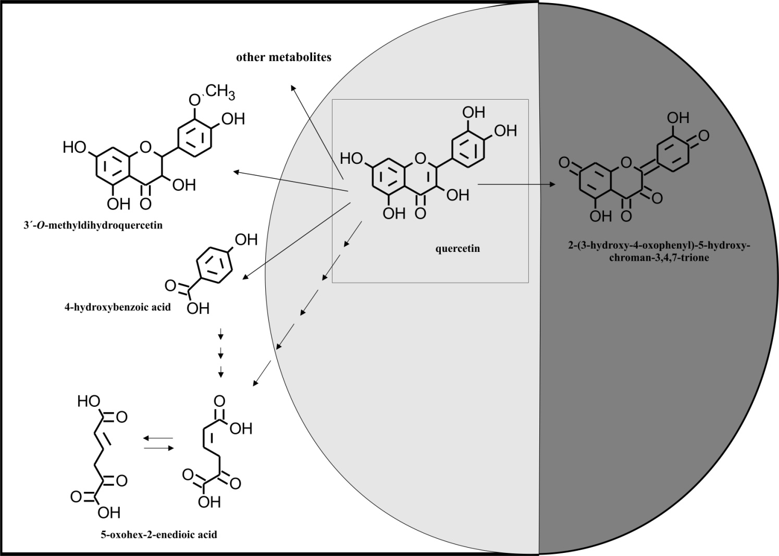
Fig 6. Suggested mechanism of quercetin metabolism by human faecal bacteria. White square represents environment of MHB, dark grey shows a place inside bacterial cell, and light gray intersection of circle and square represents a place outside as well as inside of bacteria.

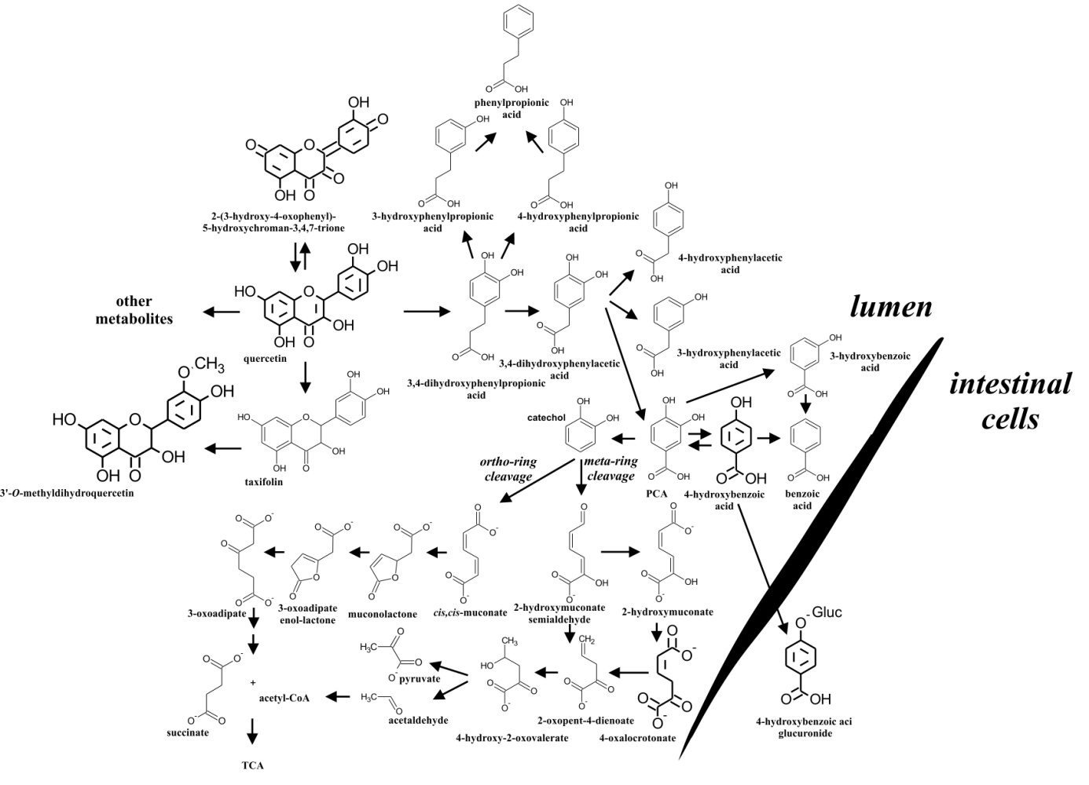
Fig. 7. Suggested mechanism of quercetin metabolism by human faecal bacteria (in a part of the intestinal lumen) and by Caco-2 cells. The mechanism is in according the literature [35, 41-49], bold molecule structures were detected in our study.
Acetyl-Co, acetyl coenzyme A; PCA, protocatechuic acid (3,4-dihydroxybenzoic acid); TCA, tricarboxylic acid cycle.

Metabolism of cyanidin-3-O-glucoside and cyanidin-3-O-galactoside by human faecal bacteria

Results show that glycosides of cyanidin were not measured inside bacteria, even after 20 hours in experimental samples. Their poor presence was detected only after 6 h incubation in MHB (and also in control sample with parent compound after 20 h as a positive control). Therefore, the parent compounds were measurable after 20 hours in control sample but almost all content of substrates was converted to metabolites during 20 h incubation in experimental samples. Seven metabolites formed by human faecal bacteria were observed by LC/MS after incubation with both cyanidin glycosides (Table 2). In general, the loss of sugar moiety was observed in all metabolites but the aglycone alone was not detected. Probably, the sugar moiety was split from the parent compound by enzymes, β-glycosidases, and remaining aglycone was immediately converted to metabolites that were measured inside and/or outside bacteria.
According to literature, cyanidin-3-O-glucoside and cyanidin-3-O-galactoside are immediately deglycosylated in the small intestine and the corresponding aglycones are rapidly absorbed; however, their systematic bioavailability is quite low. The reason is probably due to an extensive first pass metabolism and thus they enter the systematic circulation already in the form of their metabolites [50-52]. For example, cyanidin-3-O-glucoside reaches detectable plasma concentrations already 15 minutes after oral administration; nevertheless, according to Czank et al. only 12.38 % of the intact compound is absorbed via several active transport mechanisms including bilitranslocase transporter (BTL), SGLT1, mono-carboxylated transporter type 1 (MCT1), and glucose transporters (GLUTs) [11, 53]. Metabolites formed by methylation, glucuronidation, or sulfation reach blood circulation and they are then significantly excreted back into the intestinal lumen via MRP2 protein or other transport proteins located in the enterocytes [14, 54-58]. In spite of the rapid metabolism of these compounds, there is still a small part of intact compounds that are not absorbed and are present in the human large intestine [53]. That is why we decided for the study of these compounds. And probably, as our results show, also the small part of intact compounds that are not absorbed in the small intestine can be metabolized by intestinal microflora.
Three metabolites were measured inside as well as outside of bacteria. Reactions included in these metabolic processes were a reduction by hydrogen and/or by a loss of oxygen or a decomposition of parent compounds to 3,4-dihydroxybenzoic acid, also known as a protocatechuic acid. It was a major metabolite of cyanidin glycosides with [M-H]⁻ 153 observed in MHB after 6 h as well as 20 h incubation. This acid was also to a small extent measured inside of bacteria but this formation was probably caused by conditions of the incubation and preparation of samples. Protocatechuic acid is already known as a metabolite of anthocyanins [59]. Besides its formation by an action of faecal bacteria, it can be also created spontaneously, as we observed in our study and also it was already published in scientific papers [60, 61]. Effects of protocatechuic acid have been already studied. It has antioxidant, antiatherosclerotic, antiviral, antifibrotic, and anticancer effects. It could be used as an anti-ulcer drug, for a treatment of hyperpigmentation as a skin lightening, also it can significantly decrease degenerating neuronal cell death, additionally it could also be used as a good preservative for food [62-64]. This acid has however much more effects.
Other metabolite was measured as 2,4,5-trihydroxybenzaldehyde that has the same [M-H]⁻ 153 as protocatechuic acid. It was detected in a small amount only in MHB after 20 h incubation. Both metabolites, protocatechuic acid and 2,4,5-trihydroxybenzaldehyde, were identified using commercial standards (Fig. 8). Authors Chen et al. [65] already published that cyanidin glycosides are metabolized to 2,4,6-trihydroxybenzaldehyde by intestinal microflora. However, their study was performed by rats and the rat intestinal microflora can be different to human intestinal microflora. The metabolite 2,4,6-trihydroxybenzaldehyde was also detected in our experimental samples; nevertheless, its presence was observed in control sample with cyanidin glycoside as well. In our study with human faecal bacteria, the formation of 2,4,6-trihydroxybenzaldehyde was caused by spontaneously degradation of cyanidin glycoside (or as a product created by experimental conditions – an effect of pH, temperature), contrarily to 2,4,5-trihydroxybenzaldehyde that was not found in control samples.
Commercial standards for other metabolites were not available; therefore, structures of following metabolites were suggested on the basis of ions measured by LC/MS and their elementary composition. Suggested metabolite 5-hydroxy-2-(4-hydroxyphenyl)-2H-chromen-3,7-dione ([M-H]⁻ 269) was detected after 6 h as well as after 20 h incubation only in MHB, not inside bacteria. Interestingly, similar metabolite but probably more hydroxylated compared with previous one was suggested as 3,5,7-trihydroxy-2-(3,4-dihydroxyphenyl)-2H-chromene ([M-H]⁻ 287). It was observed only after 20 h incubation in MHB as well as inside bacteria (or on their surface). On the other hand, metabolite with the [M-H]⁻ 253 suggested as 5-hydroxy-2-phenyl-2H-chromen-3,7-dione was found after 6 and 20 hours in MHB and also in or on bacterial cells. It seems that 5-hydroxy-2-(4-hydroxyphenyl)-2H-chromen-3,7-dione was formed at first of these three suggested metabolites by a loss of hydroxyl group and it was further dehydroxylated to 5-hydroxy-2-phenyl-2H-chromen-3,7-dione. This metabolite entered into bacteria cells or on their surface where was hydroxylated the other way around. In this case, an effect of pH probably plays a role in changes of molecule structure. Considering that experiments were performed in MHB that has a neutral pH, metabolites could have rearranged double bonds in molecule structure compared to the environment with the low pH [59, 66]. Dehydroxylated metabolites probably had rearranged double bonds due to pH of MHB and thus they were determined as compounds with two keto groups (suggested and shown in Fig. 9). On the other hand, 3,5,7-trihydroxy-2-(3,4-dihydroxyphenyl)-2H-chromene was measured in the enol-form, this metabolite was probably present in close proximity of bacteria cells for longer time and thus this effect was caused by different extracellular pH of bacteria compared to the pH of MHB. The bacterial extracellular pH is more variable then intracellular (cytoplasmic) pH and can be changed due to several factors, such as the growth phase of bacteria, the physiology and optimum pH of bacteria, or a metabolism itself may also change the extracellular pH [67]. Mechanisms that regulate extracellular as well as intracellular pH can be a coupling transmembrane proton movements to an energetically favourable exchange with cations (K⁺, Na⁺) or anions (Cl⁻), or metabolic switching to generate acidic or neutral end-products [68]. For this reason, the pH in extracellular space can change. We have seen these little changes in molecular structure because samples were not acidified during their preparation for LC/MS determination. Then we could estimate the mechanism of bacterial metabolism of these compounds. The mechanism consists in the hydrogenation of compounds due to a lower pH (due to the presence of H⁺ ions) and in the hydroxylation that could by caused by hydrogen peroxide that is formed in bacterial cells.
Other two unknown metabolites with [M-H]⁻ 281 and with the elementary composition C₁₃H₁₄O₇ were observed only in MHB after 6 h as well as 20 h incubation. All metabolites measured in this study are probably only a small part of a much larger group of metabolites, as shown in Fig. 11. This figure was supplemented with metabolites from the literature (not bold signed). Although, these metabolites were not observed in our study, they helped to complete some metabolic pathways.

Table 2. LC/MS screening of cyanidin-3-O-glucoside and cyanidin-3-O-galactoside metabolites present outside or inside faecal bacteria after 6 or 20 h incubation.
Elementary composition | Retention time  [min] | Measured m/z | Conversion of cyanidin-3-O-glucoside and cyanidin-3-O-galactoside  to metabolite  (semiquantitative evaluation) |  |  |  |  | Reaction of metabolite formation | Possible metabolite
 |  |  | MHB |  | Bacteria
 |  |  | 6 h | 20 h |  | 6 h | 20 h
C₁₃H₁₄O₇ | 1.02 | 281.0661 | + | + |  | - | - | decomposition | M₃
C₁₃H₁₄O₇ | 1.16 | 281.0661 | + | + |  | - | - | decomposition | M₄
C₇H₆O₄ | 1.20 | 153.0193 | ++ | ++ |  | + | - | decomposition | 3,4-dihydroxybenzoic acid
C₁₅H₁₂O₆ | 1.31 | 287.0556 | - | + |  | - | + | deglycosylation, hydrogenation | 3,5,7-trihydroxy-2-(3,4-dihydroxyphenyl)-2H-chromene
C₇H₆O₄ | 1.36 | 153.0193 | - | + |  | - | - | decomposition | 2,4,5-trihydroxy-benzaldehyde
C₁₅H₁₀O₄ | 2.81 | 253.0501 | + | + |  | + | + | deglycosylation, dehydroxylation | 5-hydroxy-2-phenyl-2H-chromen-3,7-dione
C₁₅H₁₀O₅ | 5.21 | 269.0450 | + | + |  | - | - | deglycosylation, dehydroxylation | 5-hydroxy-2-(4-hydroxyphenyl)-2H-chromen-3,7-dione
M₃ and M₄ represent unknown metabolites. Signs show the conversion of cyanidin-3-O-glucoside or cyanidin-3-O-galactoside to metabolite in the sample: -, 0 %; +, 1 – 9 %; ++, 10 - 19 %.
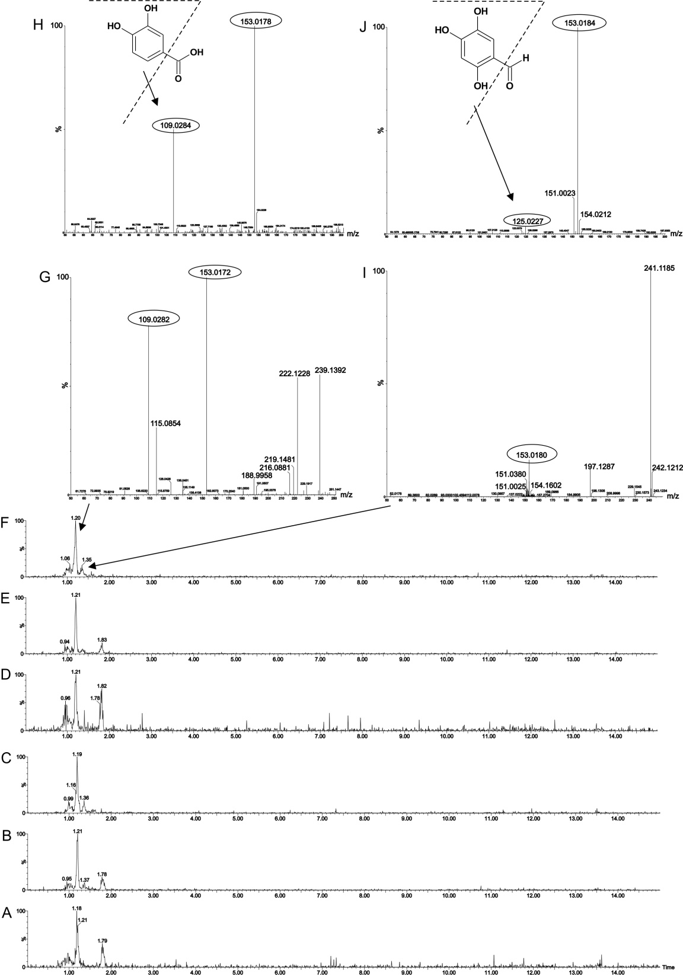
Fig. 8. Representative LC chromatograms of control sample with cyanidin-3-O-glucoside (A) and its experimental samples incubated 6 h (B) and 20 h (C). Representative LC chromatograms of control sample with cyanidin-3-O-glalactoside (D) and its experimental samples incubated 6 h (E) and 20 h (F). Figure above represents MS spectrum of signal detected in 1.20 min (H) and in 1.36 min in experimental samples. The m/z marked in a circle in mass spectrum corresponds with [M-H]⁻ of 3,4-dihydroxybenzoic acid and 2,4,5-trihydroxybenzaldehyde (structures are shown).

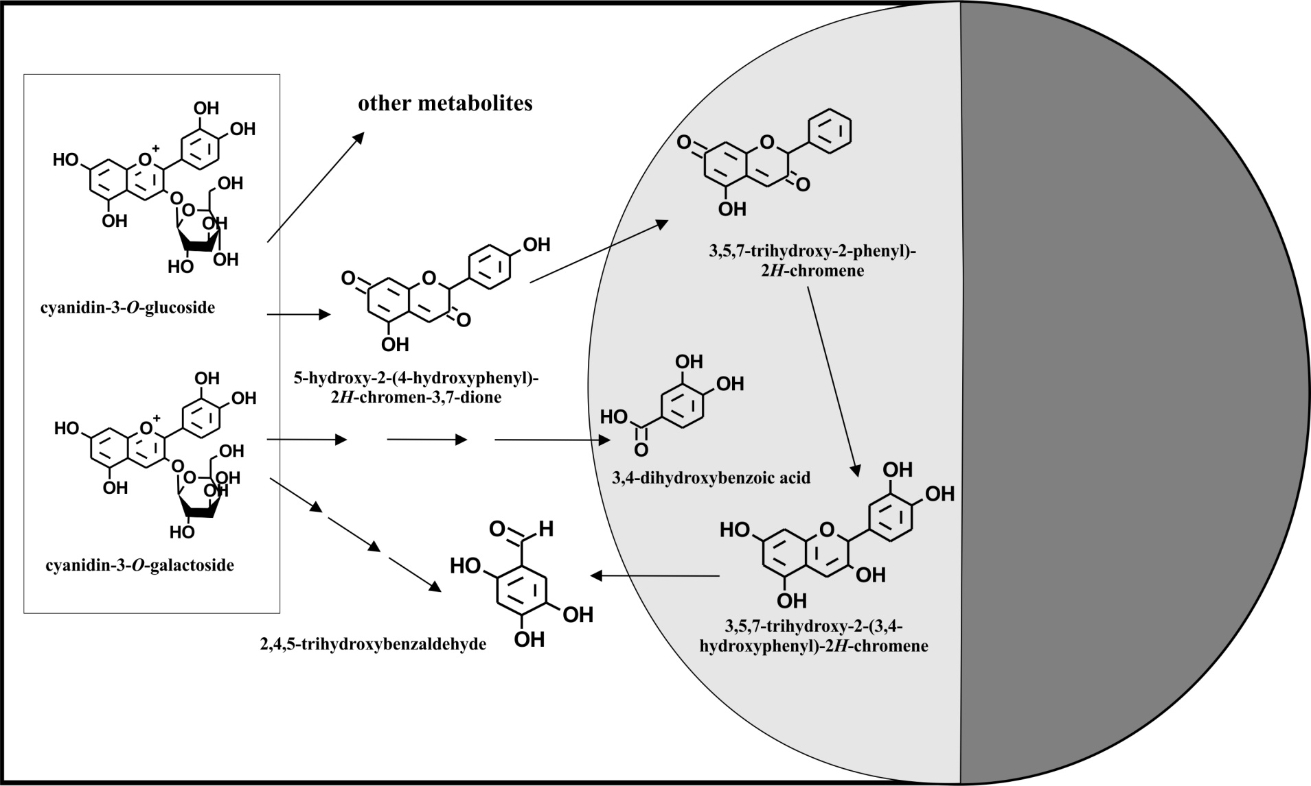

Fig. 9. Suggested mechanism of cyanidin glycosides metabolism by human faecal bacteria. White square represents environment of MHB, dark grey shows a place inside bacterial cell, and light gray intersection of circle and square represents a place outside as well as inside of bacteria.

Metabolism of metabolites of cyanidin glycosides by Caco-2 cells
Our other aim was to find out if metabolites measured in this study can enter into intestinal cells and can be further metabolized, similarly as in quercetin metabolite. Our study show that 3,4-dihydroxybenzoic acid was further O-methylated in Caco-2 cell lines and its formation was observed after 6 h as well as after 20 h incubation in broth, not inside Caco-2 cells. Indeed, a decrease in the concentration of 3,4-dihydroxybenzoic acid after 6 h (-5 %) as well as after 20 h (-25 %) was observed (Fig. 10A). Metabolite 2,4,5-trihydroxybenzaldehyde was also further metabolized in these cells and its metabolites were detected after 6 as well as 20 hours in the broth. Metabolic reactions were included glucuronidation or methylation. But the parent compound was not detected neither after 6 h nor 20 h incubation in all samples (also in control sample with parent compound). 2,4,5-trihydroxybenzaldehyde is not obviously stable compound; however, metabolites measured in broth from Caco-2 cell lines were observed only in experimental samples, not in control samples. Thus, metabolites were formed by intestinal enzymes. Third compound used in Caco-2 cells experiment was 2,4,6-trihydroxybenzaldehyde. This metabolite was not observed in experiment with cyanidin glycosides but it is known as metabolite of anthocyanins. That is why it was used for Caco-2 cells experiment. Our results show that 2,4,6-trihydroxybenzaldehyde was glucoronated and their glucuronides were determined after 6h (-22 % of parent compound) as well as 20 h (-88 % of parent compound) in broth (Fig. 10B). Their presence was also observed after 6 h in or on Caco-2 cell lines. Parent compound was detected in/on Caco-2 cells as well. All metabolites have been drawn into suggested pathways of cyanidin glycosides metabolism in Fig. 11.
A | B
Fig. 10. Metabolism of 3,4-dihydroxybenzoic acid (A) and 2,4,6-trihydroxybenzaldehyde (B) by Caco-2 cells during 6 h and 20 h incubation and their decomposition.
In samples with 3,4-dihydroxybenzoic acid, a toxic effect on the Caco-2 cells was observed after 20 h incubation. The toxic effect could be caused by O-methylated metabolite that was formed during 6 h but more during 20 h incubation. More pronounced effect on the Caco-2 cells was observed in 2,4,6-trihydroxybenzaldehyde. It is already known that 2,4,6-trihydroxybenzaldehyde inhibits cell proliferation of Caco-2 cells [69] and this effect was also observed in our experiment after 6 h as well as 20 h. Despite the toxic effect of 2,4,6-trihydroxybenzaldehyde on Caco-2 cells, glucuronides of parent compound was observed after 6 as well as 20 h incubation. Parent compound alone was moreover decomposed by experimental conditions. Thus this compound is not very stable. Similarly, 2,4,5-trihydroxybenzaldehyde is not also stable because it was not detected after 6 h anymore. Its effect on the Caco-2 cells was also toxic but only after 6 h. During the next 14 h, Caco-2 cells looked good again. This effect was probably due to a degradation of parent compound which means its toxic effect on cells thus disappeared. All detected metabolites were not present in control samples and their formation was caused by enzymes of Caco-2 cells.

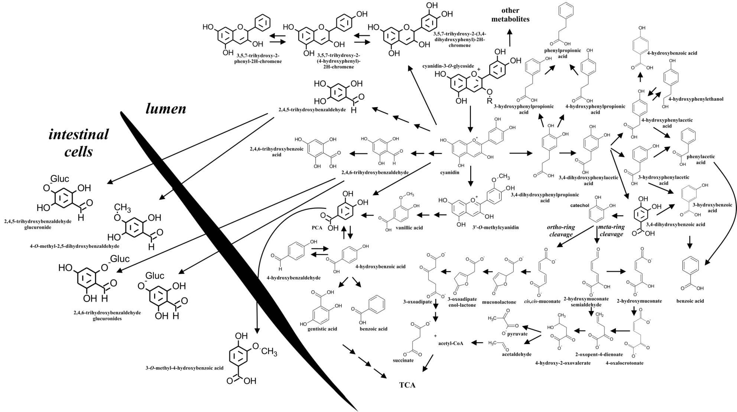
Fig. 11. Suggested mechanism of cyanidin glycosides metabolism by human faecal bacteria (in a part of the intestinal lumen) and by Caco-2 cells. The mechanism is in according the literature [49, 65, 70, 71], bold molecule structures were detected in our study. Acetyl-Co, acetyl coenzyme A; Gluc, glucuronic acid; PCA, protocatechuic acid (3,4-dihydroxybenzoic acid); TCA, tricarboxylic acid cycle.

Metabolism of delphinidin-3-O-galactoside by human faecal bacteria
Despite the similarity of delphinidin-3-O-galactoside and cyanidin3-O-galactoside (in the glycone), delphinidin-3-O-galactoside was less metabolized in our experiments. The main metabolism took place on the aglycone. A content of parent compound was partly transformed into 2,4,6-trihydroxybenzaldehyde (identified with the use of commercial standard, Fig. 12) by an action of bacterial enzymes but the remaining delphinidin-3-O-galactoside content was spontaneously degraded to gallic acid and other unknown metabolites. Delphinidin-3-O-galactoside as a parent compound has not been detected inside or outside bacteria. Even it was not present in control sample (broth with the parent compound).
Metabolite 2,4,6-trihydroxybenzaldehyde formed by faecal bacteria was measured only in MHB after 6 h incubation. In the case of cyanidin glycosides, 2,4,6-trihydroxybenzaldehyde (also measured outside bacteria) was formed spontaneously. But in the case of delphinidin-3-O-galactoside, the metabolite was not present in all control samples and thus this was created by bacteria. It seems to be a small change in molecule structure (one hydroxyl group more) can change the whole metabolic pathway.

Metabolism of metabolites of delphinidin-3-O-galactoside by Caco-2 cells

The metabolism of 2,4,6-trihydroxybenzaldehyde, as a metabolite of delphinidin-3-O-galactoside, by Caco-2 cells was studied. The results have been already shown and described in the section of Metabolism of metabolites of cyanidin glycosides by Caco-2 cells.

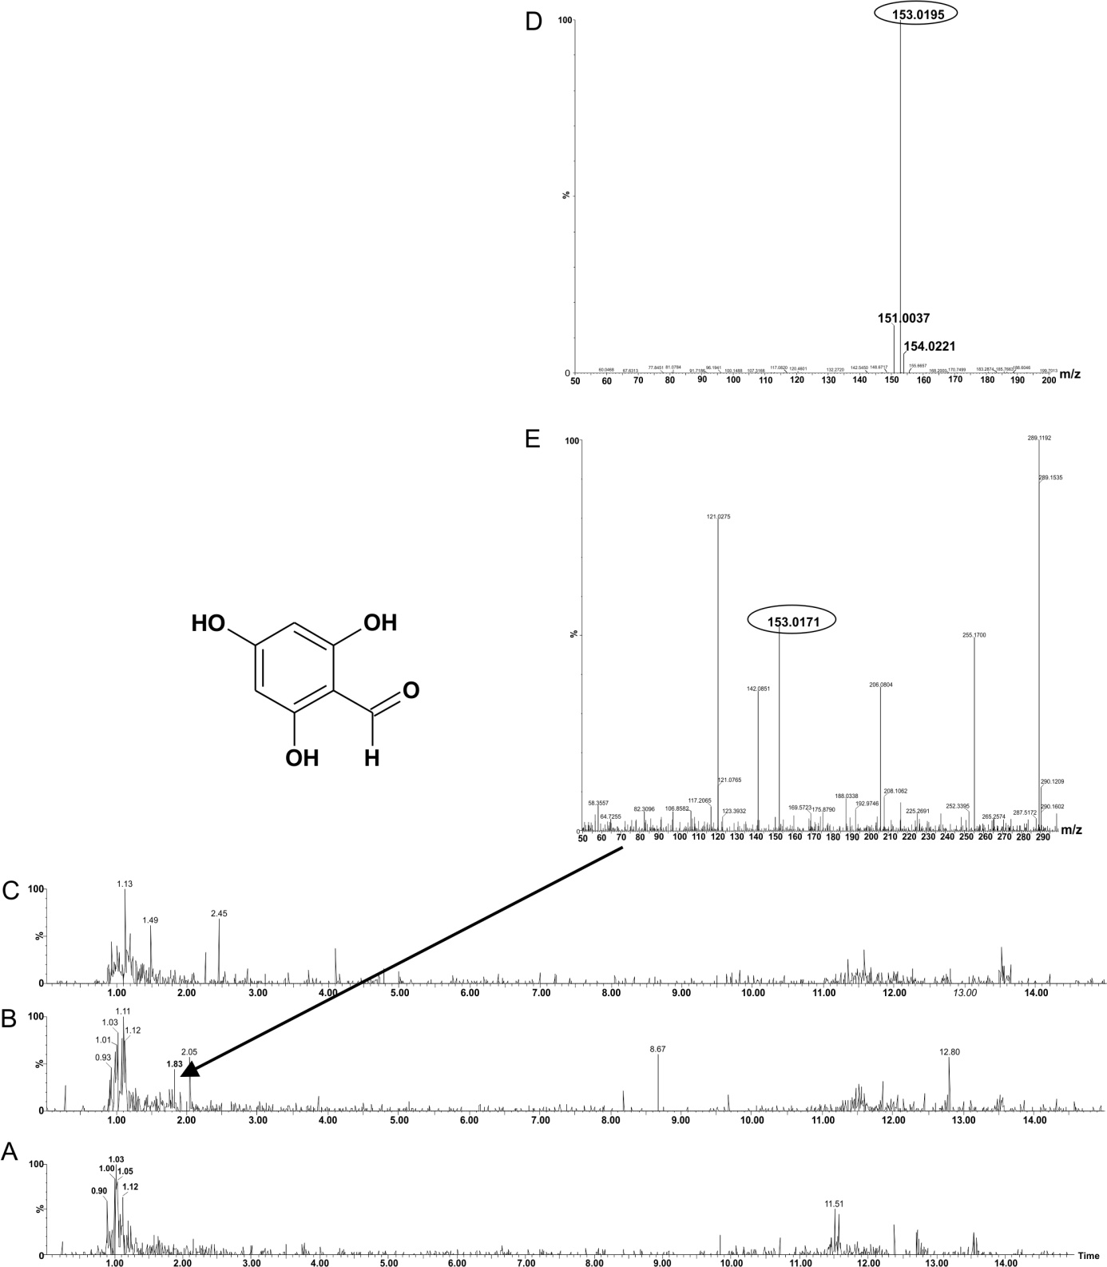
Fig. 12. Representative LC chromatograms of control sample with delphinidin-3-O-galactoside (A) and its experimental samples incubated 6 h (B) and 20 h (C). Figure above represents MS spectrum of standard 2,4,6-trihydroxybenzaldehyde (D) and signal detected in 1.83 min in experimental sample (E). The m/z marked in a circle in mass spectrum corresponds with [M-H]⁻ of 2,4,6-trihydroxybenzaldehyde, its structure is shown.

Summary and conclusions

In conclusion, this work showed the possible pathways leading to the formation of metabolites from naturally occurring polyphenols and polyphenol glycosides by intestinal microflora and what is happening with these metabolites in the intestine. Main metabolic pathways were deglycosylation, hydrogenation, methylation, hydroxylation, and decomposition. Metabolites created from natural compounds in the intestine can further pass into intestinal barrier and can be metabolized in the intestinal cells. Metabolites formed by faecal bacteria were glucuronidated or methylated by intestinal enzymes. This metabolite profiling of natural compounds has helped to better understand their metabolism in the intestine in man.

Conflict of interest statement

All authors declare no potential conflict of interest.

Funding

This work was funded by a programme AKTION Czech Republic - Austria (84p16).

References
1. Cencic A, Chingwaru W: The Role of Functional Foods, Nutraceuticals, and Food Supplements in Intestinal Health. Nutrients 2010, 2:611-625.
2. Slavin JL, Lloyd B: Health Benefits of Fruits and Vegetables. Advances in Nutrition 2012, 3:506-516.
3. Pandey KB, Rizvi SI: Plant polyphenols as dietary antioxidants in human health and disease. Oxidative Medicine and Cellular Longevity 2009, 2:270-278.
4. Li AN, Li S, Zhang YJ, Xu XR, Chen YM, Li HB: Resources and Biological Activities of Natural Polyphenols. Nutrients 2014, 6:6020-6047.
5. Shahidi F, Yeo J: Bioactivities of Phenolics by Focusing on Suppression of Chronic Diseases: A Review. International Journal of Molecular Sciences 2018, 19:16.
6. Lee EJ, Patil BS, Yoo KS: Antioxidants of 15 onions with white, yellow, and red colors and their relationship with pungency, anthocyanin, and quercetin. Lwt-Food Science and Technology 2015, 63:108-114.
7. FM M, M A, W A: Quercetin-A Mini Review. Modern Concepts & Developments in Agronomy 2018, 1:1-5.
8. Database. In Phenol-Explorer, Database on polyphenol content in food: Food composition.
9. Fabio G, Luca LF, Paola V, Vincenzo F, Luca V, Catherine F: Bioavailability, antioxidant and biological properties of the natural free-radical scavengers cyanidin and related glycosides Annali dell'Istituto Superiore di Sanità 2007, 43:382-393.
10. McGhie TK, Walton MC: The bioavailability and absorption of anthocyanins: Towards a better understanding. Molecular Nutrition & Food Research 2007, 51:702-713.
11. Olivas-Aguirre FJ, Rodrigo-Garcia J, Martinez-Ruiz ND, Cardenas-Robles AI, Mendoza-Diaz SO, Alvarez-Parrilla E, Gonzalez-Aguilar GA, de la Rosa LA, Ramos-Jimenez A, Wall-Medrano A: Cyanidin-3-O-glucoside: Physical-Chemistry, Foodomics and Health Effects. Molecules 2016, 21:30.
12. Donaldson GP, Lee SM, Mazmanian SK: Gut biogeography of the bacterial microbiota. Nature Reviews Microbiology 2016, 14:20-32.
13. Holzapfel WH, Haberer P, Snel J, Schillinger U, Huis in't Veld JHJ: Overview of gut flora and probiotics. International Journal of Food Microbiology 1998, 41:85-101.
14. Almeida AF, Borge GIA, Piskula M, Tudose A, Tudoreanu L, Valentova K, Williamson G, Santos CN: Bioavailability of Quercetin in Humans with a Focus on Interindividual Variation. Comprehensive Reviews in Food Science and Food Safety 2018, 17:714-731.
15. Aura AM, Martin-Lopez P, O'Leary KA, Williamson G, Oksman-Caldentey KM, Poutanen K, Santos-Buelga C: In vitro metabolism of anthocyanins by human gut microflora. European Journal of Nutrition 2005, 44:133-142.
16. Langendijk PS, Schut F, Jansen GJ, Raangs GC, Kamphuis GR, Wilkinson MHF, Welling GW: QUANTITATIVE FLUORESCENCE IN-SITU HYBRIDIZATION OF BIFIDOBACTERIUM SPP WITH GENUS-SPECIFIC 16S RIBOSOMAL-RNA-TARGETED PROBES AND ITS APPLICATION IN FECAL SAMPLES. Applied and Environmental Microbiology 1995, 61:3069-3075.
17. Suau A, Bonnet R, Sutren M, Godon JJ, Gibson GR, Collins MD, Dore J: Direct analysis of genes encoding 16S rRNA from complex communities reveals many novel molecular species within the human gut. Applied and Environmental Microbiology 1999, 65:4799-4807.
18. Guarner F, Malagelada JR: Gut flora in health and disease. Lancet 2003, 361:512-519.
19. Beckers L, Hiligsmann S, Hamilton C, Masset J, Thonart P: Fermentative hydrogen production by Clostridium butyricum CWBI1009 and Citrobacter freundii CWBI952 in pure and mixed cultures. Biotechnologie Agronomie Societe Et Environnement 2010, 14:541-548.
20. Huycke MM, Abrams V, Moore DR: Enterococcus faecalis produces extracellular superoxide and hydrogen peroxide that damages colonic epithelial cell DNA. Carcinogenesis 2002, 23:529-536.
21. Portela CAF, Smart KF, Tumanov S, Cook GM, Villas-Boas SG: Global Metabolic Response of Enterococcus faecalis to Oxygen. Journal of Bacteriology 2014, 196:2012-2022.
22. Cesselin B, Derre-Bobillot A, Fernandez A, Lamberet G, Lechardeur D, Yamamoto Y, Pedersen MB, Garrigues C, Gruss A, Gaudu P: Responses of Lactic Acid Bacteria to Oxidative Stress. In Stress Responses of Lactic Acid Bacteria. Edited by Tsakalidou E, Papadimitriou K. New York: Springer; 2011: 111-127: Food Microbiology and Food Safety].
23. Espey MG: Role of oxygen gradients in shaping redox relationships between the human intestine and its microbiota. Free Radical Biology and Medicine 2013, 55:130-140.
24. Qin JJ, Li RQ, Raes J, Arumugam M, Burgdorf KS, Manichanh C, Nielsen T, Pons N, Levenez F, Yamada T, et al: A human gut microbial gene catalogue established by metagenomic sequencing. Nature 2010, 464:59-U70.
25. Schloissnig S, Arumugam M, Sunagawa S, Mitreva M, Tap J, Zhu A, Waller A, Mende DR, Kultima JR, Martin J, et al: Genomic variation landscape of the human gut microbiome. Nature 2013, 493:45-50.
26. Braune A, Blaut M: Bacterial species involved in the conversion of dietary flavonoids in the human gut. Gut Microbes 2016, 7:216-234.
27. Gaya P, Peiroten A, Landete JM: Transformation of plant isoflavones into bioactive isoflavones by lactic acid bacteria and bifidobacteria. Journal of Functional Foods 2017, 39:198-205.
28. Jeet D, Sanjib M: A Review on Probiotics. Scholars Academic Journal of Biosciences 2016, 4:549-554.
29. Wood IS, Trayhurn P: Glucose transporters (GLUT and SGLT): expanded families of sugar transport proteins. British Journal of Nutrition 2003, 89:3-9.
30. Hollman PCH: Absorption, bioavailability, and metabolism of flavonoids. Pharmaceutical Biology 2004, 42:74-83.
31. Kasikci MB, Bagdatlioglu N: Bioavailability of Quercetin. Current Research in Nutrition and Food Science 2016, 4:146-151.
32. Gee JM, DuPont MS, Day AJ, Plumb GW, Williamson G, Johnson IT: Intestinal transport of quercetin glycosides in rats involves both deglycosylation and interaction with the hexose transport pathway. Journal of Nutrition 2000, 130:2765-2771.
33. Viskupicva J, Ondrejovic M, Sturdik E: Bioavailability and metabolism of flavonoids. Journal of Food and Nutrition Research 2008, 47:151-162.
34. Sala-Trepat JM, Evans WC: META CLEAVAGE OF CATECHOL BY AZOTOBACTER SPECIES - 4-OXALOCROTONATE PATHWAY. European Journal of Biochemistry 1971, 20:400-+.
35. Nesvera J, Rucka L, Patek M: Catabolism of Phenol and Its Derivatives in Bacteria: Genes, Their Regulation, and Use in the Biodegradation of Toxic Pollutants. In Advances in Applied Microbiology, Vol 93. Volume 93. Edited by Sariaslani S, Gadd GM. San Diego: Elsevier Academic Press Inc; 2015: 107-160: Advances in Applied Microbiology].
36. Harwood CS, Parales RE: The beta-ketoadipate pathway and the biology of self-identity. Annual Review of Microbiology 1996, 50:553-590.
37. Yang P, Xu F, Li HF, Wang Y, Li FC, Shang MY, Liu GX, Wang X, Cai SQ: Detection of 191 Taxifolin Metabolites and Their Distribution in Rats Using HPLC-ESI-IT-TOF-MSn. Molecules 2016, 21:26.
38. Lee YJ, Kim BG, Park Y, Lim Y, Hur HG, Ahn JH: Biotransformation of flavonoids with O-methyltransferase from Bacillus cereus. Journal of Microbiology and Biotechnology 2006, 16:1090-1096.
39. Claus H, Decker H: Bacterial tyrosinases. Systematic and Applied Microbiology 2006, 29:3-14.
40. Bhusan MB, Satyendra G: Polyphenol oxidases: Biochemical and molecular characterization, distribution, role and its control Enzyme Engineering 2016, 5:141.
41. Ornston LN: CONVERSION OF CATECHOL AND PROTOCATECHUATE TO BETA-KETOADIPATE BY PSEUDOMONAS PUTIDA .2. ENZYMES OF PROTOCATECHUATE PATHWAY. Journal of Biological Chemistry 1966, 241:3787-3794.
42. Robert-Gero M, Poiret M, Stanier RY: FUNCTION OF BETA-KETOADIPATE PATHWAY IN PSEUDOMONAS ACIDOVORANS. Journal of General Microbiology 1969, 57:207-+.
43. Braune A, Gutschow M, Engst W, Blaut M: Degradation of quercetin and luteolin by Eubacterium ramulus. Applied and Environmental Microbiology 2001, 67:5558-5567.
44. Olthof MR, Hollman PCH, Buijsman M, van Amelsvoort JMM, Katan MB: Chlorogenic acid, quercetin-3-rutinoside and black tea phenols are extensively metabolized in humans. Journal of Nutrition 2003, 133:1806-1814.
45. Rechner AR, Smith MA, Kuhnle G, Gibson GR, Debnam ES, Srai SKS, Moore KP, Rice-Evans CA: Colonic metabolism of dietary polyphenols: Influence of structure on microbial fermentation products. Free Radical Biology and Medicine 2004, 36:212-225.
46. Selma MV, Espin JC, Tomas-Barberan FA: Interaction between Phenolics and Gut Microbiota: Role in Human Health. Journal of Agricultural and Food Chemistry 2009, 57:6485-6501.
47. Del Rio D, Rodriguez-Mateos A, Spencer JPE, Tognolini M, Borges G, Crozier A: Dietary (Poly)phenolics in Human Health: Structures, Bioavailability, and Evidence of Protective Effects Against Chronic Diseases. Antioxidants & Redox Signaling 2013, 18:1818-1892.
48. Motilva MJ, Macia A, Romero MP, Rubio L, Mercader M, Gonzalez-Ferrero C: Human bioavailability and metabolism of phenolic compounds from red wine enriched with free or nano-encapsulated phenolic extract. Journal of Functional Foods 2016, 25:80-93.
49. Zhu YS, Sun HJ, He SD, Lou QY, Yu M, Tang MM, Tu LJ: Metabolism and prebiotics activity of anthocyanins from black rice (Oryza sativa L.) in vitro. Plos One 2018, 13:15.
50. Wiczkowski W, Romaszko E, Piskula MK: Bioavailability of Cyanidin Glycosides from Natural Chokeberry (Aronia melanocarpa) Juice with Dietary-Relevant Dose of Anthocyanins in Humans. Journal of Agricultural and Food Chemistry 2010, 58:12130-12136.
51. Fang J: Bioavailability of anthocyanins. Drug Metabolism Reviews 2014, 46:508-520.
52. Goszcz K, Deakin SJ, Duthie GG, Stewart D, Megson IL: Bioavailable Concentrations of Delphinidin and Its Metabolite, Gallic Acid, Induce Antioxidant Protection Associated with Increased Intracellular Glutathione in Cultured Endothelial Cells. Oxidative Medicine and Cellular Longevity 2017:17.
53. Czank C, Cassidy A, Zhang QZ, Morrison DJ, Preston T, Kroon PA, Botting NP, Kay CD: Human metabolism and elimination of the anthocyanin, cyanidin-3-glucoside: a C-13-tracer study. American Journal of Clinical Nutrition 2013, 97:995-1003.
54. Tsuda T, Horio F, Osawa T: Absorption and metabolism of cyanidin 3-O-beta-D-glucoside in rats. Febs Letters 1999, 449:179-182.
55. O'Leary KA, Day AJ, Needs PW, Mellon FA, O'Brien NM, Williamson G: Metabolism of quercetin-7-and quercetin-3-glucuronides by an in vitro hepatic model: the role of human beta-glucuronidase, sulfotransferase, catechol-O-methyltransferase and multi-resistant protein 2 (MRP2) in flavonoid metabolism. Biochemical Pharmacology 2003, 65:479-491.
56. van der Woude H, Boersma MG, Vervoort J, Rietjens I: Identification of 14 quercetin phase II mono- and mixed conjugates and their formation by rat and human phase II in vitro model systems. Chemical Research in Toxicology 2004, 17:1520-1530.
57. Ichiyanagi T, Rahman MM, Kashiwada Y, Ikeshiro Y, Shida Y, Hatano Y, Matsumoto H, Hirayama M, Tsuda T, Konishi T: Absorption and metabolism of delphinidin 3-O-beta-D-glucopyranoside in rats. Free Radical Biology and Medicine 2004, 36:930-937.
58. Wang WY, Sun CX, Mao LK, Ma PH, Liu FG, Yang J, Gao YX: The biological activities, chemical stability, metabolism and delivery systems of quercetin: A review. Trends in Food Science & Technology 2016, 56:21-38.
59. Dangles O, Fenger JA: The Chemical Reactivity of Anthocyanins and Its Consequences in Food Science and Nutrition. Molecules 2018, 23:23.
60. Keppler K, Humpf HU: Metabolism of anthocyanins and their phenolic degradation products by the intestinal microflora. Bioorganic & Medicinal Chemistry 2005, 13:5195-5205.
61. Kamiloglu S, Capanoglu E, Grootaert C, Van Camp J: Anthocyanin Absorption and Metabolism by Human Intestinal Caco-2 Cells-A Review. International Journal of Molecular Sciences 2015, 16:21555-21574.
62. Sahil K, Souravh B: A review on protocatechuic acid and its pharmacological potential. ISRN Pharmacology 2014, 2014:1-9.
63. Truong XT, Park SH, Lee YG, Jeong HY, Moon JH, Jeon TI: Protocatechuic Acid from Pear Inhibits Melanogenesis in Melanoma Cells. International Journal of Molecular Sciences 2017, 18:10.
64. Kho AR, Choi BY, Lee SH, Hong DK, Jeong JH, Park KH, Song HK, Choi HC, Suh SW: Effects of Protocatechuic Acid (PCA) on Global Cerebral Ischemia-Induced Hippocampal Neuronal Death. International Journal of Molecular Sciences 2018, 19:19.
65. Chen Y, Li Q, Zhao T, Zhang Z, Mao GH, Feng WW, Wu XY, Yang LQ: Biotransformation and metabolism of three mulberry anthocyanin monomers by rat gut microflora. Food Chemistry 2017, 237:887-894.
66. Ozdal T, Sela DA, Xiao JB, Boyacioglu D, Chen F, Capanoglu E: The Reciprocal Interactions between Polyphenols and Gut Microbiota and Effects on Bioaccessibility. Nutrients 2016, 8:36.
67. Rubén S-C, Isabel IM, G. PA, Isabel GM, Faustino M, Rafael B: Study of pH changes in media during bacterial growth of several environmental strains Proceedings 2018, 2:1-5.
68. Slonczewski JL, Fujisawa M, Dopson M, Krulwich TA: Cytoplasmic pH Measurement and Homeostasis in Bacteria and Archaea. In Advances in Microbial Physiology, Vol 55. Volume 55. Edited by Poole RK. London: Academic Press Ltd-Elsevier Science Ltd; 2009: 1-79: Advances in Microbial Physiology].
69. Forester SC, Waterhouse AL: Gut Metabolites of Anthocyanins, Gallic Acid, 3-O-Methylgallic Acid, and 2,4,6-Trihydroxybenzaldehyde, Inhibit Cell Proliferation of Caco-2 Cells. Journal of Agricultural and Food Chemistry 2010, 58:5320-5327.
70. W. JC, Davinia S, Payal K, Holly S, J. PD, T. BG: Enhancing muconic acid production from glucose and lignin-derived aromatic compounds via increased protocatechuate decarboxylase activity. Metabolic Engineering Communications 2016, 3:111-119.
71. Williamson G, Kay CD, Crozier A: The Bioavailability, Transport, and Bioactivity of Dietary Flavonoids: A Review from a Historical Perspective. Comprehensive Reviews in Food Science and Food Safety 2018, 17:1054-1112.

