REPORT

about the AKTION project Nr. 63p1

Possibilities of sustainable re-use of urban brownfields in Brno and Graz

A comparison of the situation stated within another AKTION project elaborated in 1996 – 1999 concerning old burdens in the eastern part of the city of Brno was the main idea of the project. The methodology which was used in the first investigation mentioned was delivered by the Austrian colleagues.
The team of young researcher was changed because the change of PhD. students in the period between project submission and the period of its solution. Ing. Jana Žitňáková and Ing. Iva Křenovská participated in the research from the Czech side.
The solution of the project included following stages:

- Study stages of the Czech PhD. students in the Karl-Franzens-Universität in Graz and the Austrian researchers in Brno.
The aim of the stage was: familiarization of the team, clarification of methodology, excursion into the areas under study. Additionally, the stay of Austrian researchers (W. Fischer and Jaume Vidal Rubi) was connected with the participation in the international conference EURORURAL ´12 and some lectures for the students of the Mendel University with the topic Recycling of brownfields.

- Investigation of the brownfield areas in Brno
Repeated investigation of selected sites of old burdens was the central point of the empiric stage of the project. The sites were visited and documented. All changes were registered. The results were consulted with the responsible officer of the Magistrate of the City of Brno.
In view of the title of the project the investigation was not limited with the comparative Study. The attention was paid also to industrial brownfields in the eastern part of Brno – namely Svitava industrial zone and Královopolská strojírna Machinery. In the first case, the course of transformation of individual areas in the zone was analyzed and generalized. In the second case, some solution of the transformation was suggested.
Theoretical basement and generalization of results obtained was an integral part of the results.

- Dissemination of the project results
Following publication is the main result of the project:
Vaishar, A., Šťastná, M., Zapletalová, J., Emminger, H., Křenovská, I., Lorková, H., Žitňáková, J.: Staré zátěže a brownfieldy v prostoru Brno-východ. Brno: Mendelova univerzita v Brně, 48 p.
The publication summarizes all results mentioned above. The Magistrate of Brno is interested in obtaining the output because of lack of precise information especially about the development of old burdens sites.
A set of lectures for the Mendel university students was read by the project participants on the topic:
Křenovská, I.: Brownfields revitalization
Žitňáková, J.: Old burdens in the area Brno-East
The dissemination is not considered as completed. A preparation of an article for a chosen Czech journal is intended.

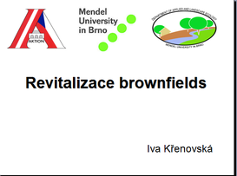 | 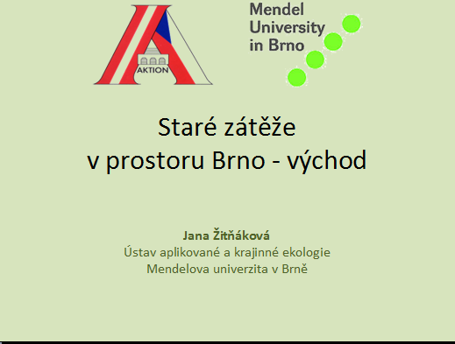
Úvodní strany prezentací pro studenty

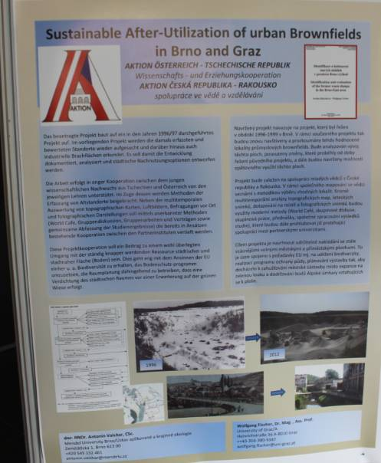
Poster exhibited within the EURORURAL ´12 Conference in September 2012.
***
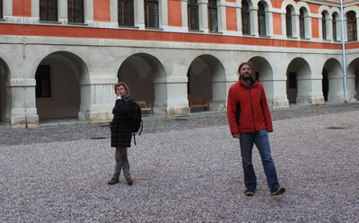 | 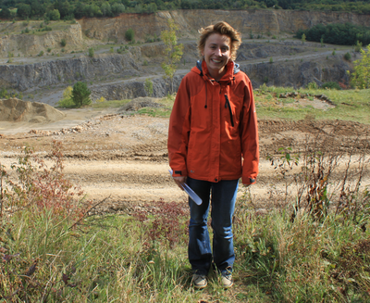
From the stay in Graz: Iva Křenovská and Helmut Emminger | Filed works in Brno: Iva Křenovská.

Financial sources were spent as in the project submission with exception of travel expenses of the Czech participants. The amount of CZK 5,228,- was returned to the provider. The reason is that domestic travelling was combined with other projects and not drawn from the AKTION project.

Brno, January 28, 2013 Antonín Vaishar

